* **BJT(Bipolar Junction Transistor):-**
* The bjt (bipolar junction transistor)is a type of transistor that is a current control device used to get an amplified current in the output With the help of input current .
* As the name suggests bipolar means that the current here flows due to both majority and minority carriers.
* It is a three terminal device ( emitter ,base , collector ).The collector is the widest region followed by emitter and the thinnest region is base (i.e. collector >emitter > base ).
* This is because the collector has to take the electrons or holes that are emitted from the emitter whereas the base is the thinest as it has to make the holes or electrons travel from it.
* **Construction of bjt:-**
* It can be construed by using two diodes and both the diodes should be attached in the circuit such that both the diodes are in series and are oppositely facing (i.e. the n side of diodes are combined or p side of diodes are combined). Hence will form a bjt .
* **SYMBOL OF BJT:-**

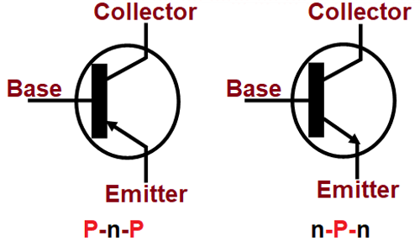

IN NPN THE CURRENT FLOWS FROM EMIITER TO BASE HENCE ARROW IS IN OUTWARD DIRECTION.

IN PNP THE CURRENT FLOWS FROM EMITTER TO BASE HENCE ARROW IS IN INWARD DIRECTION.

**Working principal:-**

* The first junction that is the emitter base region should be forward bias and the second junction that is base collector that should be reverse bias .
* **Types of bjt :-**
* There are two types of bjt :-
* NPN bipolar junction transistor
* PNP bipolar junction transistor
* **NPN bipolar junction transistor:-**
* As the name suggests it is the type of transistor where the p side of both the diodes is combined and now it is a common region for both the diodes.
* **Working of NPN :-**
* The emitter and base region is forward bias by connecting negative side of battery to the emitter and the positive side to base and in second junction the positive side of another battery to collector and negative side of battery to the base. Due to this the electrons flow from the emitter to the base as electrons of the battery and the electrons of the emitter repel each other . As a result the IE current is formed and the electrons now move from the base to the collector and only 5 percent will get recombined and the remaining 95 percent reach to the collector and hence the IC current will form and hence the current will be more amplified as the electrons are continuously emitted by emitter .

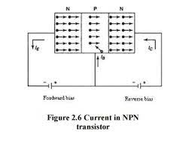

* **CURRENT EQUATION:-**

BY KCL=

IE =IC+IB

* **PNP bipolar junction transistor:-**
* As the name suggests it is the type of transistor where the n side of both the diodes is combined and now it is a common region for both the diodes.
* **Working of PNP:-**
* The emitter and base region is forward bias by connecting the positive side of the battery to the emitter and the negative side to the base and in the second junction the negative side of another battery to the collector and positive side of the battery to the base. Due to this the holes flow from the emitter to the base as holes of the battery and the holes of the emitter repel each other . As a result the IE current is formed and the holes now move from the base to the collector and only 5 percent will get recombined and the remaining 95 percent reach to the collector and hence the IC current will form and hence the current will be more amplified as the holes are continuously emitted by emitter .

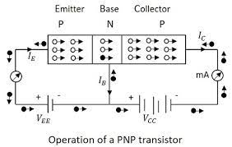

* **CURRENT EQUATION:-**

BY KCL=

IE =IC+IB

* **Application of bjt**

1. PREFERRED TRANSISTOR FOR the logic GATE.
2. CAN BE USED AS AMPLIFIERS.
3. CAN BE USED IN OSSILATOR CIRCUITS.
4. preferred in the multi-vibrator circuits.
5. CAN BE USED IN CLIPPING AND TIME DELAY CIRCUITS.
6. USED AS SWITCHING CIRCUITS.